 | Cambridge Mathematics Stage 2  Name: ………………………………………………….  Class: …………… Date: ……………………… /27
Homework- Unit 1: Numbers to 100
- Write the missing numbers:
1.1
25 | 26 |  |  | 29 |  | 31 |  | 33
/5
1.2 Count on in 2s:
2 | 4 |  |  | 10 |  | 14 |  | 18
/5
1.3 Count on in 2s:
60 | 62 | 64 |  |  |  | 72 | 74
/5
- Count the blocks and fill in the numbers:
0. | 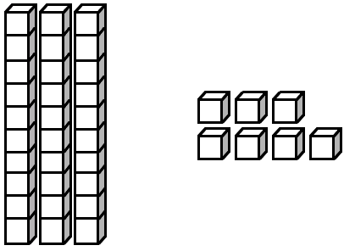   | 30  3 7  7 | 1. |        | _ _  _ _  _
2. |        | _ _  _ _  _ | 3. |          | _ _  _ _  _
/3

- Look at the numbers. Order them from the smallest to the biggest number:
0. | 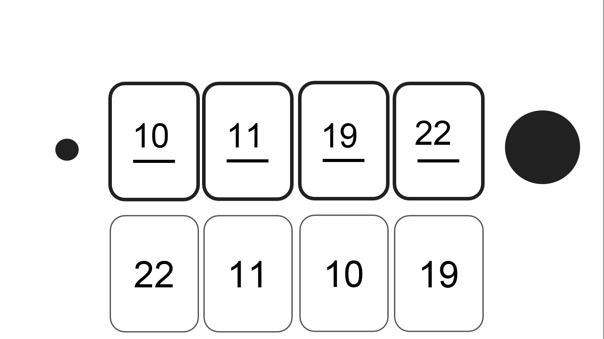 | 1. | 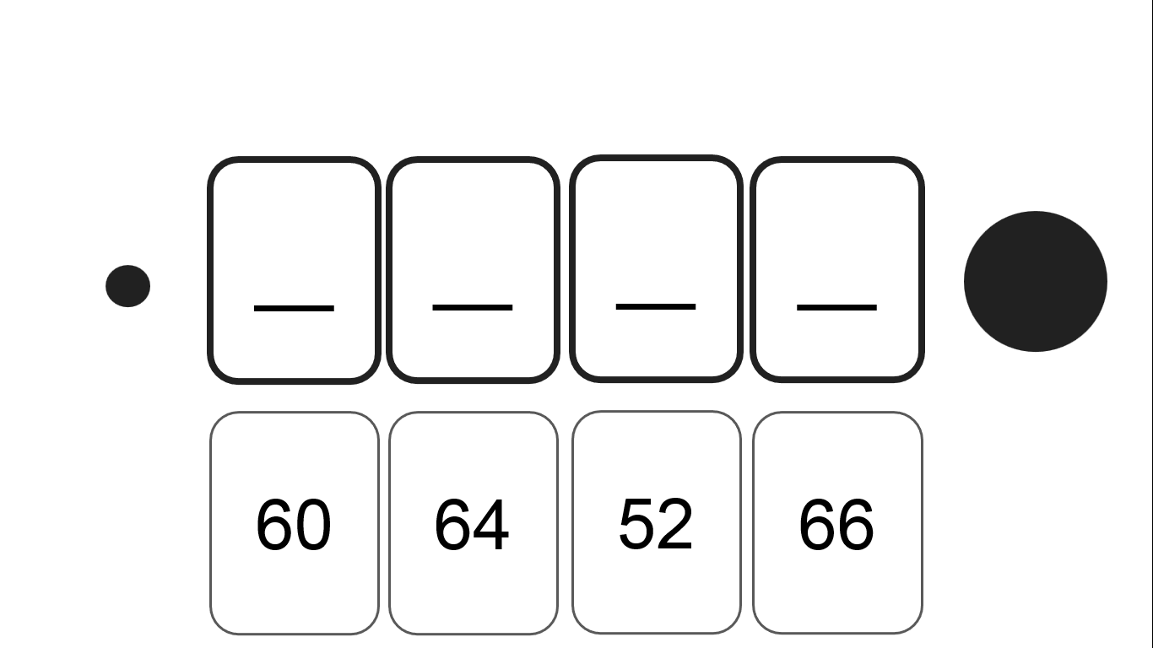
2. | 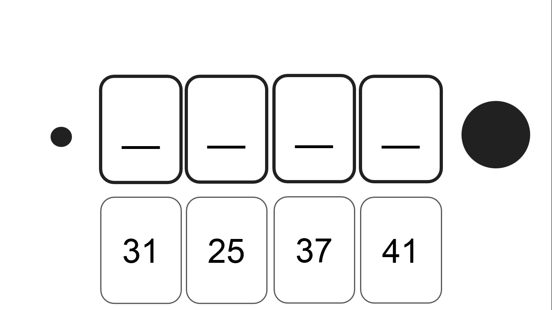 | 3. | 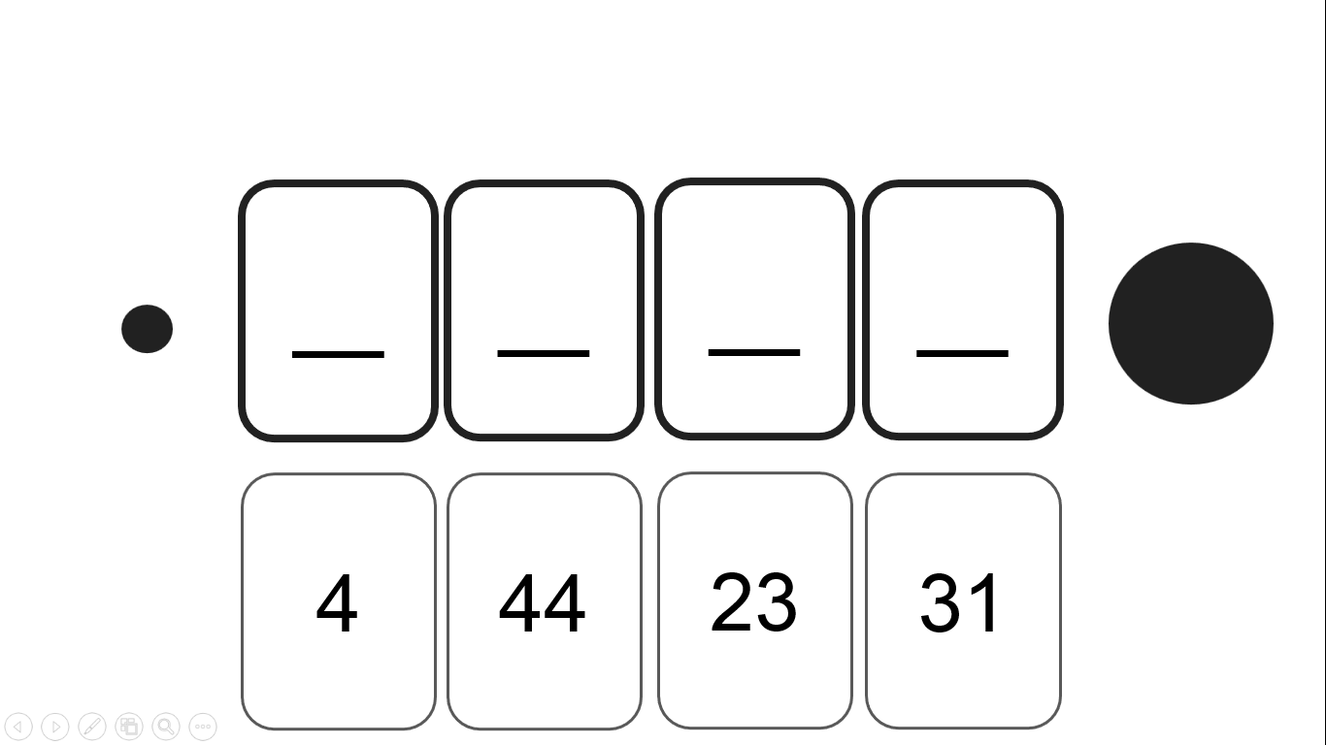
/3
- Order the numbers from biggest to smallest:
0. | 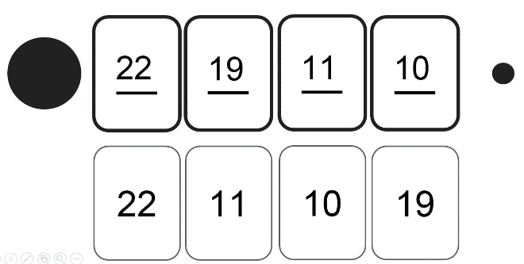 | 1. | 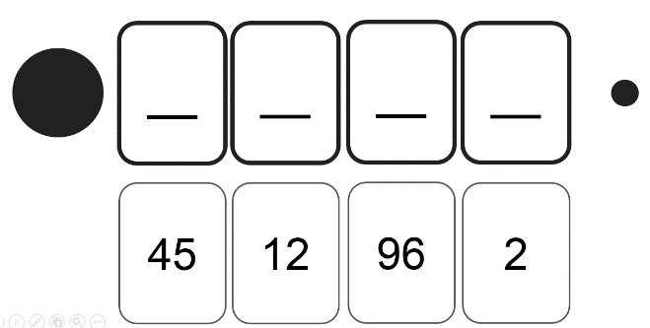
2. | 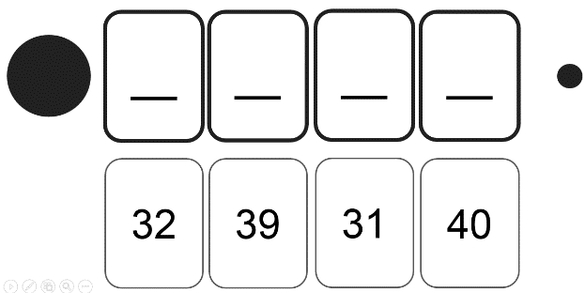 | 3. | 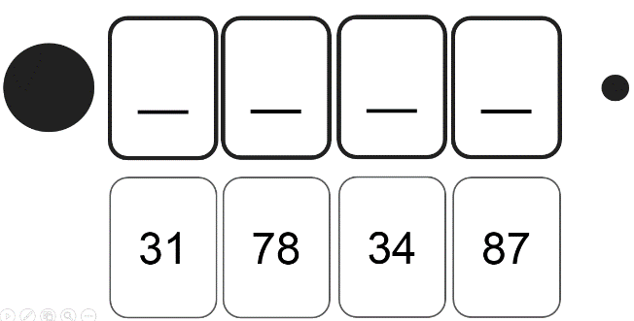
/3
- Look at the number line. Circle the value of a, b and c:
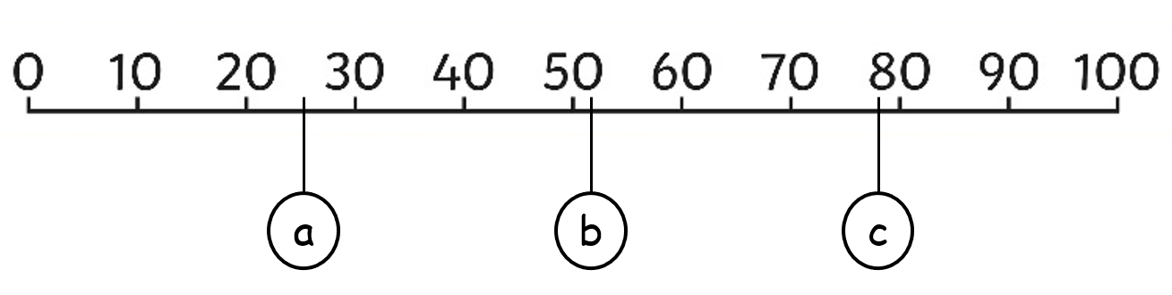

/3
A: 22 | 29 | 25 | B: 50 | 52 | 57 | C: 78 | 72 | 82

